GUIDEBEE
Map Server API Developer Guide
On Java ME platform



James Shen
www.guidebee.biz
Guidebee Biz.

ISSUE/AMENDMENT STATUS

Issue | Date | Description | Author
1.0 | 08th Dec 2007 | First Version | James Shen jing.shen@guidebee.biz

TABLE OF CONTENTS
ISSUE/AMENDMENT STATUS 2
1.0 Overview of Guidebee Map Server Java ME API 4
1.1 Package gis 4
1.2 Package gis.geometry 5
1.3 Package gis.server 5
2.0 Map Basics 7
2.1 The "Hello, World" of ServerMap 7
2.1.1 Define a canvas to draw the map 9
2.1.2 Define a map downloader object to download map tiles from Server 9
2.1.3 Define the ServerMap Object. 9
2.1.4 Initializing the Map 9
2.1.5 Define a map downloader callback to monitor the downloading progress 9
3.0 Map Operation 10
3.1 Set Map Type 10
3.2 Zoom In/Zoom Out 12
3.3 Map Pan 14
3.4 Map image cache 16
4.0 Map Services 17
4.1 GeoCoding 17
4.2 Driving Direction 19
5.0 Put All things together –Pocket Streets 23
6.0 Licence 24

- Overview of Guidebee Map Server Java ME API
Guidebee Map Server Java ME API implements a mobile GIS engine for J2ME platform (CLDC/MIDP). It provides a subset of Google Map API.
With Guidebee Map (Server) Java ME API, a MIDlet can connect to map servers (like Yahoo map, Microsoft Live Map etc) and display map image, find an address and get a direction.
It includes following 3 sub packages:
- biz.guidebee.gis
- biz.guidebee.gis.geometry
- biz.guidebee.gis.server
  - Package gis
Package gis define some common Map Objects:
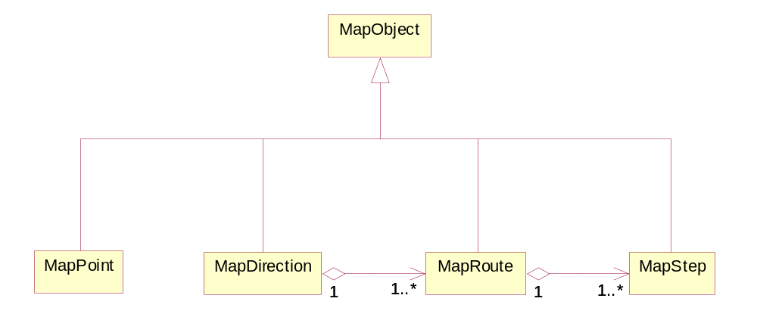
MapDirection | This class is used to store driving directions results
MapObject | Base class of all map objects.
MapPoint | Class MapPoint stands for a point map object.
MapRoute | Objects of this class store information about a single route in a directions result.
MapStep | Objects of this class store information about a single step within a route in a directions result.

  - Package gis.geometry
This package defines geographical geometry objects, like polygon, point, polyline etc.

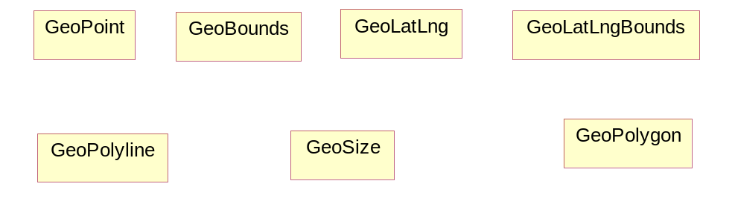
GeoBounds | GeoBounds is a rectangular area of the map in pixel coordinates
GeoLatLng | GeoLatLng is a point in geographical coordinate’s longitude and latitude.
GeoLatLngBounds | GeoLatLng is a bound in geographical coordinate’s longitude and latitude.
GeoPoint | A point representing a location in (x,y) coordinate space, specified in integer precision.
GeoPolygon | Polygon on map.
GeoPolyline | Polyline on map.
GeoSize | The GeoSize class encapsulates the width and height of a component (in integer precision) in a single object.
  - Package gis.server
The server package defines object used to query from GIS server.
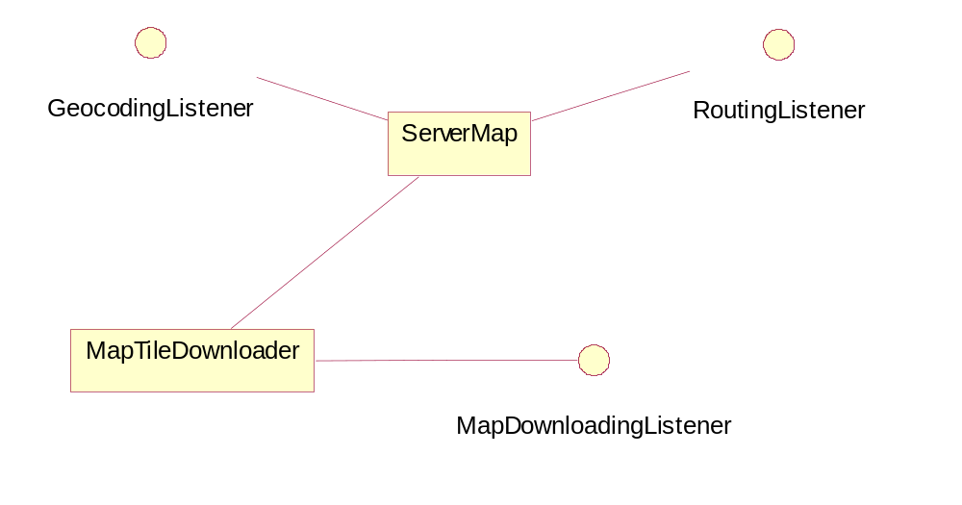

GeocodingListener | Callback when geocoding query is finished.
MapDownloadingListener | Callback when downloading map tiles.
RoutingListener | Callback when routing query is finished.
MapTileDownloader | MapTileDownloader download map image tiles from server (msn, yahoo, etc).
ServerMap | ServerMap a map class uses to display map from GIS server.
- Map Basics
The fundamental element in any Guidebee Maps (Server) API application is the "ServerMap" itself. This section discusses usage of the fundamental ServerMap object and the basics of map operations
  - The "Hello, World" of ServerMap
The following example displays a map center at James Street, Perth, Australia.

//--------------------------------- PACKAGE ---------------------------
package biz.guidebee.gis.example;

//--------------------------------- IMPORTS ---------------------------
import javax.microedition.midlet.*;
import javax.microedition.lcdui.*;

import biz.guidebee.gis.*;
import biz.guidebee.gis.geometry.*;
import biz.guidebee.gis.server.*;

import biz.guidebee.licence.InvalidLicenceException;

class MapCanvas extends Canvas{
ServerMap map=null;
MapCanvas(ServerMap map){
this.map=map;
}

protected void drawMapImage(Graphics g){
Image image=map.getMapImage();
g.drawImage(image,0,0,Graphics.TOP|Graphics.LEFT);
}

protected void paint(Graphics g){
drawMapImage(g);
}
}

//[------------------------------ MAIN CLASS --------------------------
public class HelloWorld extends MapServerMIDlet implements MapDownloadingListener{

/**
* The display object associated with the MIDlet.
*/
private Display display;

/**
* The Canvas object.
*/
private MapCanvas canvas;

private ServerMap map;

private MapTileDownloader mapTileDownloader;

/** Creates a new instance of HelloWorld */
public HelloWorld() throws InvalidLicenceException{
super();
display = Display.getDisplay(this);
mapTileDownloader=new MapTileDownloader(this);
map=new ServerMap(mapWidth,mapHeight,mapTileDownloader);
canvas = new MapCanvas(map);
}

public void startApp() throws MIDletStateChangeException {
display.setCurrent(canvas);
GeoLatLng center=new GeoLatLng(-31.948275,115.857562);
map.setCenter(center,13,mapTileDownloader.MICROSOFTMAP);
canvas.repaint();
}

public void pauseApp(){

}

public void destroyApp(boolean unconditional)
throws MIDletStateChangeException {

}

public void readProgress(int bytes,int total){
System.out.println("Reading " + bytes + "/" + total);
}
}

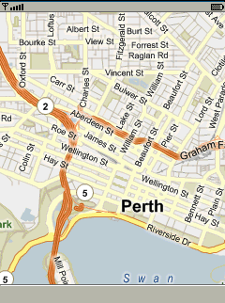
Even in this simple example, there are five things to note:
- Define a canvas to draw the map.
- Define a map downloader instance to download the map tiles from Map Server.
- Define a ServerMap instance to create a new “Map” object.
- Center the map on a given geographic point.
- Define a map downloader callback to monitor the downloading progress.
These steps are explained below.
    - Define a canvas to draw the map
In the example, we define a MapCanva which extends from Canvas. It takes ServerMap as parameter for the constructor.
In it’s paint methods
Image image=map.getMapImage();
g.drawImage(image,0,0,Graphics.TOP|Graphics.LEFT);
First get the map Image from the ServerMap object, and then draw it to the canvas.
    - Define a map downloader object to download map tiles from Server
ServerMap needs a map downloader object to download map tiles from map server. The Guidebee Map(Server)API provides a default MapDownloader object which can be used to download map tiles from Yahoo,Microsoft etc map server. You can define your own map downloader to get map tiles from other servers.
To monitor the downloader progress, a MapdownloaderListerner is needed for the MapDownloader.
    - Define the ServerMap Object.
ServerMap’s constructor is defined as following:
public ServerMap(int width,
int height,
MapTileDownloader downloader)
throws biz.guidebee.licence.InvalidLicenceException
width and height defines the width and height of the map ,normally it’s the width and height of the canvas.
    - Initializing the Map
GeoLatLng center=new GeoLatLng(-31.948275,115.857562);
map.setCenter(center,13,mapTileDownloader.MICROSOFTMAP);
setCenter() method requires a GLatLng coordinate and a zoom level and this method must be sent before any other operations are performed on the map.
setCenter() also specify the map type, it can be Yahoo ,Microsoft Map or Satellite Map etc. In this example we use Microsoft Live Map.
    - Define a map downloader callback to monitor the downloading progress
Downloading map tiles from Map server takes times (it depends on the network connection speed) ,it’d be good let user know the downloading is going on. MapDownloaderListener defines one callback readProgress gives the total bytes to be downloaded and the bytes already downloaded, in this example, we just print it out.
public void readProgress(int bytes,int total){
System.out.println("Reading " + bytes + "/" + total);
}

Note: the super class MapServerMIDlet is a direct subclass of MIDlet; it just feeds the correct licence information for using Guidee Map (Server) API.
- Map Operation
ServerMap has methods to zoom/pan the map.
  - Set Map Type
In the “Hello, World” example, we specify the map type when calling setCenter(). We can also call setMapType to change the type of map be shown. From different map server (Yahoo, Microsoft etc) or (Normal Map, Satellite Map, Hybrid map).
The following example show different map type in sequence.

package biz.guidebee.gis.example;

//--------------------------------- IMPORTS ------------------------------------
import javax.microedition.midlet.*;
import javax.microedition.lcdui.*;

import biz.guidebee.gis.*;
import biz.guidebee.gis.geometry.*;
import biz.guidebee.gis.server.*;

import biz.guidebee.licence.InvalidLicenceException;

class MapTypeCanvas extends Canvas implements CommandListener{
ServerMap map=null;
private int maptype=0;
private static int []mapTypes={MapTileDownloader.MICROSOFTSATELLITE,
MapTileDownloader.MICROSOFTMAP,
MapTileDownloader.MICROSOFTHYBRID};
private Command mapType=new Command("MapType",Command.OK,1);

MapTypeCanvas(ServerMap map){
this.map=map;
addCommand(mapType);
setCommandListener(this);
}

protected void drawMapImage(Graphics g){
Image image=map.getMapImage();
g.drawImage(image,0,0,Graphics.TOP|Graphics.LEFT);
}

protected void paint(Graphics g){
drawMapImage(g);
}

public void commandAction(Command command, Displayable displayable) {
// for Tool command
if (command == mapType) {
map.setMapType(mapTypes[maptype]);
repaint();
maptype++;
maptype %=3;
}
}
}

//[------------------------------ MAIN CLASS ----------------------------------]
////////////////////////////////////////////////////////////////////////////////
public class MapType extends MapServerMIDlet implements MapDownloadingListener{

/**
* The display object associated with the MIDlet.
*/
private Display display;

/**
* The Canvas object.
*/
private MapTypeCanvas canvas;

private ServerMap map;

private MapTileDownloader mapTileDownloader;

/** Creates a new instance of MapType */
public MapType() throws InvalidLicenceException{
super();
display = Display.getDisplay(this);
mapTileDownloader=new MapTileDownloader(this);
map=new ServerMap(mapWidth,mapHeight,mapTileDownloader);
canvas = new MapTypeCanvas(map);

}

public void startApp() throws MIDletStateChangeException {
display.setCurrent(canvas);
GeoLatLng center=new GeoLatLng(-31.948275,115.857562);
map.setCenter(center,13,mapTileDownloader.MICROSOFTMAP);
canvas.repaint();
}

public void pauseApp(){

}

public void destroyApp(boolean unconditional)
throws MIDletStateChangeException {

}

public void readProgress(int bytes,int total){
System.out.println("Reading " + bytes + "/" + total);
}
}

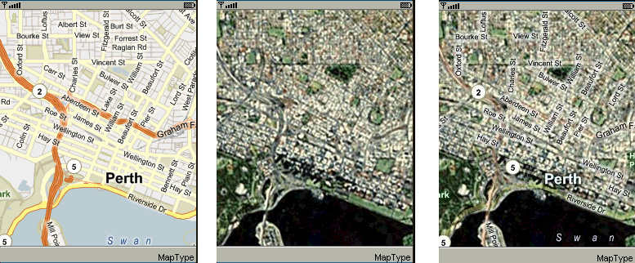
  - Zoom In/Zoom Out
The following examples display how to zoom in/Zoom out map.

//--------------------------------- PACKAGE ------------------------------------
package biz.guidebee.gis.example;

//--------------------------------- IMPORTS ------------------------------------
import javax.microedition.midlet.*;
import javax.microedition.lcdui.*;

import biz.guidebee.gis.*;
import biz.guidebee.gis.geometry.*;
import biz.guidebee.gis.server.*;

import biz.guidebee.licence.InvalidLicenceException;

class MapZoomCanvas extends Canvas implements CommandListener{
ServerMap map=null;
private Command cmdZoomIn=new Command("ZoomIn",Command.ITEM,1);
private Command cmdZoomOut=new Command("ZoomOut",Command.ITEM,1);

MapZoomCanvas(ServerMap map){
this.map=map;
addCommand(cmdZoomIn);
addCommand(cmdZoomOut);
setCommandListener(this);
}

protected void drawMapImage(Graphics g){
Image image=map.getMapImage();
g.drawImage(image,0,0,Graphics.TOP|Graphics.LEFT);
}

protected void paint(Graphics g){
drawMapImage(g);
}

public void commandAction(Command command, Displayable displayable) {
// for Tool command
if (command == cmdZoomIn) {
map.zoomIn();
repaint();
}
if (command == cmdZoomOut) {
map.zoomOut();
repaint();
}
}
}

//[------------------------------ MAIN CLASS ----------------------------------]
////////////////////////////////////////////////////////////////////////////////
//--------------------------------- REVISIONS ----------------------------------
// Date Name Tracking # Description
// -------- ------------------- ------------- --------------------------
// 28JUL2007 James Shen Initial Creation
////////////////////////////////////////////////////////////////////////////////
/**
* Sample discription.
* <p>
* <hr><b>&copy; Copyright 2007 Guidebee, Inc. All Rights Reserved.</b>
* @version 1.00, 28/07/07
* @author Guidebee, Inc.
*/
public class MapZoom extends MapServerMIDlet implements MapDownloadingListener{

/**
* The display object associated with the MIDlet.
*/
private Display display;

/**
* The Canvas object.
*/
private MapZoomCanvas canvas;

private ServerMap map;

private MapTileDownloader mapTileDownloader;

/** Creates a new instance of MapZoom */
public MapZoom() throws InvalidLicenceException{
super();
display = Display.getDisplay(this);
mapTileDownloader=new MapTileDownloader(this);
map=new ServerMap(mapWidth,mapHeight,mapTileDownloader);
canvas = new MapZoomCanvas(map);

}

public void startApp() throws MIDletStateChangeException {
display.setCurrent(canvas);
GeoLatLng center=new GeoLatLng(-31.948275,115.857562);
map.setCenter(center,13,mapTileDownloader.MICROSOFTMAP);
canvas.repaint();
}

public void pauseApp(){

}

public void destroyApp(boolean unconditional)
throws MIDletStateChangeException {

}

public void readProgress(int bytes,int total){
System.out.println("Reading " + bytes + "/" + total);
}
}

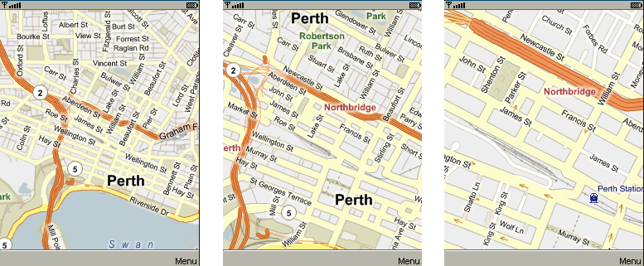
  - Map Pan
ServerMap has two pan methonds, panDirection and panTo. panTo pan the current pan to a given latitude,longtitude, panDirection move the map to some distance relative to current position.
The following example how to pan the map in up,down,left,right directions.

//--------------------------------- PACKAGE ------------------------------------
package biz.guidebee.gis.example;

//--------------------------------- IMPORTS ------------------------------------
import javax.microedition.midlet.*;
import javax.microedition.lcdui.*;

import biz.guidebee.gis.*;
import biz.guidebee.gis.geometry.*;
import biz.guidebee.gis.server.*;

import biz.guidebee.licence.InvalidLicenceException;

class MapPanCanvas extends Canvas implements CommandListener{
ServerMap map=null;
private Command cmdUp=new Command("Up",Command.ITEM,1);
private Command cmdDown=new Command("Down",Command.ITEM,1);
private Command cmdLeft=new Command("Left",Command.ITEM,1);
private Command cmdRight=new Command("Right",Command.ITEM,1);

MapPanCanvas(ServerMap map){
this.map=map;
addCommand(cmdUp);
addCommand(cmdDown);
addCommand(cmdLeft);
addCommand(cmdRight);
setCommandListener(this);
}

protected void drawMapImage(Graphics g){
Image image=map.getMapImage();
g.drawImage(image,0,0,Graphics.TOP|Graphics.LEFT);
}

protected void paint(Graphics g){
drawMapImage(g);
}

public void commandAction(Command command, Displayable displayable) {
// for Tool command
if (command == cmdUp) {
map.panDirection(0,-32);
repaint();
}
if (command == cmdDown) {
map.panDirection(0,32);
repaint();
}
if (command == cmdLeft) {
map.panDirection(-32,0);
repaint();
}
if (command == cmdRight) {
map.panDirection(32,0);
repaint();
}
}
}

//[------------------------------ MAIN CLASS ----------------------------------]
////////////////////////////////////////////////////////////////////////////////
//--------------------------------- REVISIONS ----------------------------------
// Date Name Tracking # Description
// -------- ------------------- ------------- --------------------------
// 28JUL2007 James Shen Initial Creation
////////////////////////////////////////////////////////////////////////////////
/**
* Sample discription.
* <p>
* <hr><b>&copy; Copyright 2007 Guidebee, Inc. All Rights Reserved.</b>
* @version 1.00, 28/07/07
* @author Guidebee, Inc.
*/
public class MapPan extends MapServerMIDlet implements MapDownloadingListener{

/**
* The display object associated with the MIDlet.
*/
private Display display;

/**
* The Canvas object.
*/
private MapPanCanvas canvas;

private ServerMap map;

private MapTileDownloader mapTileDownloader;

/** Creates a new instance of MapPan */
public MapPan() throws InvalidLicenceException{
super();
display = Display.getDisplay(this);
mapTileDownloader=new MapTileDownloader(this);
map=new ServerMap(mapWidth,mapHeight,mapTileDownloader);
canvas = new MapPanCanvas(map);

}

public void startApp() throws MIDletStateChangeException {
display.setCurrent(canvas);
GeoLatLng center=new GeoLatLng(-31.948275,115.857562);
map.setCenter(center,13,mapTileDownloader.MICROSOFTMAP);
canvas.repaint();
}

public void pauseApp(){

}

public void destroyApp(boolean unconditional)
throws MIDletStateChangeException {

}

public void readProgress(int bytes,int total){
System.out.println("Reading " + bytes + "/" + total);
}
}

  - Map image cache
ServerMap has some internal cache to speed up future map tiles download. If the image required is already in the cache, it reads from the internal cache memory directly. But this cache is tempory; it’s gone when application exits. If application wants to save the cache permanently. ServerMap provides two methods: saveMapCache () and restoreMapCache () to save and restore map image cache to and from a recordstore.
- Map Services
ServerMap also provides methods let application to access geocoding and routiong services from Map Server.
  - GeoCoding
Geocoding is the process of converting addresses (like "1600 Amphitheatre Parkway, Mountain View, CA") into geographic coordinates (like latitude 37.423021 and longitude -122.083739), which you can use to place markers or position the map.
The following examples show how to use the Geocoding services with ServerMap, it querys for 7 Fairway, Crawley, Australia. And then display the map in that area.

//--------------------------------- PACKAGE ------------------------------------
package biz.guidebee.gis.example;

//--------------------------------- IMPORTS ------------------------------------
import javax.microedition.midlet.*;
import javax.microedition.lcdui.*;

import biz.guidebee.gis.*;
import biz.guidebee.gis.geometry.*;
import biz.guidebee.gis.server.*;

import biz.guidebee.licence.InvalidLicenceException;

class GeocodingCanvas extends Canvas{
ServerMap map=null;
GeocodingCanvas(ServerMap map){
this.map=map;
}

protected void drawMapImage(Graphics g){
Image image=map.getMapImage();
g.drawImage(image,0,0,Graphics.TOP|Graphics.LEFT);
}

protected void paint(Graphics g){
drawMapImage(g);
}
}

//[------------------------------ MAIN CLASS ----------------------------------]
////////////////////////////////////////////////////////////////////////////////
//--------------------------------- REVISIONS ----------------------------------
// Date Name Tracking # Description
// -------- ------------------- ------------- --------------------------
// 28JUL2007 James Shen Initial Creation
////////////////////////////////////////////////////////////////////////////////
/**
* Sample discription.
* <p>
* <hr><b>&copy; Copyright 2007 Guidebee, Inc. All Rights Reserved.</b>
* @version 1.00, 28/07/07
* @author Guidebee, Inc.
*/
public class Geocoding extends MapServerMIDlet implements MapDownloadingListener,GeocodingListener{

/**
* The display object associated with the MIDlet.
*/
private Display display;

/**
* The Canvas object.
*/
private GeocodingCanvas canvas;

private ServerMap map;

private MapTileDownloader mapTileDownloader;

/** Creates a new instance of Geocoding */
public Geocoding() throws InvalidLicenceException{
super();
display = Display.getDisplay(this);
mapTileDownloader=new MapTileDownloader(this);
map=new ServerMap(mapWidth,mapHeight,mapTileDownloader);
canvas = new GeocodingCanvas(map);
}

public void startApp() throws MIDletStateChangeException {
display.setCurrent(canvas);
GeoLatLng center=new GeoLatLng(-31.948275,115.857562);
map.setCenter(center,13,mapTileDownloader.MICROSOFTMAP);
map.setGeocodingListener(this);
map.getLocations("7 Fairway,Crawley,WA 6009,Australia");
canvas.repaint();
}

public void pauseApp(){

}

public void destroyApp(boolean unconditional)
throws MIDletStateChangeException {

}

public void readProgress(int bytes,int total){
System.out.println("Reading " + bytes + "/" + total);
}

public void done(java.lang.String query,MapPoint[] result){
if(result!=null){
map.panTo(result[0].getPoint());
canvas.repaint();
}
}
}

Before calling getLocation(), a callback(or a listener) need to be setup to get the query result, ServerMap uses AJAX to make a web query and get the result with the done methods. The MapPoint[] array contains the geocoing results.

  - Driving Direction
You can get driving direction by the getDirection() method of ServerMap. Once directions are returned, the MapDirection object will internally store results which you can retrieve using MapDirection.getPolyline() and/or MapDirection.getRoute(i:Number) methods. Steps within a route can be retrieved using the MapRoute.getStep(i:Number)
Here is the example:

//--------------------------------- PACKAGE ------------------------------------
package biz.guidebee.gis.example;

//--------------------------------- IMPORTS ------------------------------------
import java.util.*;
import javax.microedition.midlet.*;
import javax.microedition.lcdui.*;

import biz.guidebee.geometry.*;
import biz.guidebee.gis.*;
import biz.guidebee.gis.geometry.*;
import biz.guidebee.gis.server.*;

import biz.guidebee.licence.InvalidLicenceException;

class DrivingDirectionCanvas extends Canvas{
ServerMap map=null;
DrivingDirectionCanvas(ServerMap map){
this.map=map;
}

private int needShowLevel(int numLevel,int zoomLevel ){
int totalZoomLevel=16;
int mapGrade=(totalZoomLevel-zoomLevel)/numLevel-1;
return mapGrade;

}

protected void drawMapImage(Graphics g) throws InvalidLicenceException{
Image image=map.getMapImage();
Vector overLays=map.getOverlays();
g.drawImage(image,0,0,Graphics.TOP|Graphics.LEFT);
for(int i=0;i<overLays.size();i++){
MapObject mapObject=(MapObject)overLays.elementAt(i);
switch(mapObject.getType()){
case MapObject.DIRECTION:
{
MapDirection mapDirection=(MapDirection)mapObject;
GeoPolyline polyline=mapDirection.polyline;
int minLevel=needShowLevel(polyline.numLevels,map.getZoom());
boolean hasPt1=false,hasPt2=false;
GeoLatLng pt1=null,pt2=null,pt;
PointD newPt1,newPt2;
int level;
Point drawPt1,drawPt2;
g.setColor(0x00FF00);
int steps = Math.max(1,polyline.getVertexCount()/100);
GeoLatLngBounds mapBounds=map.getBounds();
//mapBounds.extend(new GeoLatLng(0.1,0.1));
for(int j=0;j<polyline.getVertexCount()-1;j++){

pt=polyline.getVertex(j);
level=polyline.getLevel(j);
if(hasPt1==false){
if(level>=minLevel){
//if(mapBounds.containsLatLng(pt))
{
hasPt1=true;
pt1=pt;
continue;
}
}
}
if(hasPt1){
if(level>=minLevel){
//if(mapBounds.containsLatLng(pt))
{
hasPt2=true;
pt2=pt;
newPt1=map.fromLatLngToMapPixel(pt1);
newPt2=map.fromLatLngToMapPixel(pt2);
drawPt1=new
Point((int)newPt1.x,(int)newPt1.y);
drawPt2=new Point((int)newPt2.x,(int)newPt2.y);
g.drawLine(drawPt1.x,drawPt1.y,drawPt2.x,drawPt2.y);
hasPt1=true;
pt1=pt2;
continue;
}
}
}

}
}
break;
}
}

}

protected void paint(Graphics g){
try{
drawMapImage(g);}
catch(InvalidLicenceException e){}
}
}

//[------------------------------ MAIN CLASS ----------------------------------]
////////////////////////////////////////////////////////////////////////////////
//--------------------------------- REVISIONS ----------------------------------
// Date Name Tracking # Description
// -------- ------------------- ------------- --------------------------
// 28JUL2007 James Shen Initial Creation
////////////////////////////////////////////////////////////////////////////////
/**
* Sample discription.
* <p>
* <hr><b>&copy; Copyright 2007 Guidebee, Inc. All Rights Reserved.</b>
* @version 1.00, 28/07/07
* @author Guidebee, Inc.
*/
public class DrivingDirection extends MapServerMIDlet implements MapDownloadingListener,RoutingListener{

/**
* The display object associated with the MIDlet.
*/
private Display display;

/**
* The Canvas object.
*/
private DrivingDirectionCanvas canvas;

private ServerMap map;

private MapTileDownloader mapTileDownloader;

/** Creates a new instance of DrivingDirection */
public DrivingDirection() throws InvalidLicenceException{
super();
display = Display.getDisplay(this);
mapTileDownloader=new MapTileDownloader(this);
map=new ServerMap(mapWidth,mapHeight,mapTileDownloader);
canvas = new DrivingDirectionCanvas(map);
}

public void startApp() throws MIDletStateChangeException {
display.setCurrent(canvas);
GeoLatLng center=new GeoLatLng(-31.948275,115.857562);
map.setCenter(center,13,mapTileDownloader.MICROSOFTMAP);
map.setRoutingListener(this);
map.getDirections("from: 68 Waterloo St, Joondanna WA 6060, Australia to:7 Fairway, Crawley, Western Australia 6009, Australia");
canvas.repaint();
}

public void pauseApp(){
}

public void destroyApp(boolean unconditional)
throws MIDletStateChangeException {

}

public void readProgress(int bytes,int total){
System.out.println("Reading " + bytes + "/" + total);
}

public void done(java.lang.String query, MapDirection result){
if(result!=null){
System.out.println(query);
System.out.println(result.summary);
map.resize(result.bounds);
map.addOverlay(result);
canvas.repaint();
}
}
}

Note: Currently ServerMap’s Geocoding and Direction Services make use of Google’s web service. But it’s subject to change in the future. But the API will keep the same.
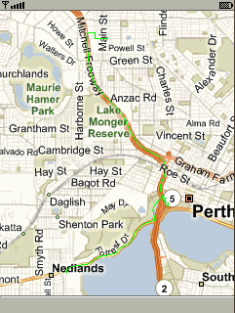
- Put All things together –Pocket Streets
Micrsoft’s Pocket Streets is one of my favorite applications, though it doesn’t provide navigation capability, but it’s my first location software ever installed in my HP PDA. Now with Guidebee Map (Server) API, we can develop a similar application on Java ME platform.
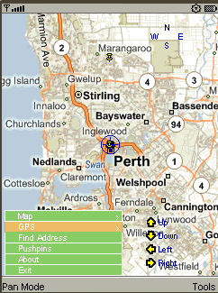
This demo provides similar functionality to Microsoft’s pocket street. Provide Map Zoom in/Zoom, Pan direction, Find address, add your own pushpin etc.
You can add GPS and navigation yourself to make it navigation software like Tomtom, Navman. I’ll leave it to your capable hands☺
Note: This demo contains some UI code which is taken from one of my coworker’s previous project (Menu, Views).if you want to resume this part of the code; you need a written permission from Guidebee, Biz. (james.shen@guidebee.biz)

- Licence
Guidebee Map (Server) API provides classes to access map services from Yahoo, Microsoft etc. before using their map service, please read their User Agreement. Your violation of their TOU is at your own risk.

Licence from Guidebee Biz. Includes two parts:
- The licence key
Gives the product name “MapServer” and licence keys, six long integers. To correctly use this library, you need to call LicenceManager to add correctly licence to the LicenceManager.
- And the licence file.
The file name is guidebee.lic, which need to put in the root directory of the resource with the MIDlet jar file.
If develops with Wireless tool kit, the licence file needs to put in the res directory. If develops with Netbean, the licence file needs to put in the src directory.

package biz.guidebee.gis.example;

//--------------------------------- IMPORTS ------------------------------------
import javax.microedition.midlet.*;
import javax.microedition.lcdui.*;
import biz.guidebee.licence.*;

class DummyCanvas extends Canvas{
protected void paint(Graphics g){

}
}
//[------------------------------ MAIN CLASS ----------------------------------]
////////////////////////////////////////////////////////////////////////////////
//--------------------------------- REVISIONS ----------------------------------
// Date Name Tracking # Description
// -------- ------------------- ------------- --------------------------
// 09DEC2007 James Shen Initial Creation
////////////////////////////////////////////////////////////////////////////////
/**
* Sample discription.
* <p>
* <hr><b>&copy; Copyright 2007 Guidebee, Inc. All Rights Reserved.</b>
* @version 1.00, 09/12/07
* @author Guidebee, Inc.
*/
public abstract class MapServerMIDlet extends MIDlet {

protected int mapHeight=0;

protected int mapWidth=0;
/** Creates a new instance of GISMIDlet */
public MapServerMIDlet() throws InvalidLicenceException {

LicenceManager licenceManager=LicenceManager.getInstance(this);
long keysGraphics2D[]= {-0x48523e11722cf1e0L,-0x7eab332624e15dacL,0x5e68724c65503e52L,0x637ab6e46b72a114L,0x6af10ba17aae79f6L,0x5828d65d6df1850L};
licenceManager.addLicence("Graphics2D",keysGraphics2D);
long keysMapServer[]= {-0x48523e11722cf1e0L,-0x7eab332624e15dacL,-0x4ff3575906afd720L,-0x71be78b1832a863cL,-0x657160b482143989L,0x3160156b2f482fe7L};
licenceManager.addLicence("MapServer",keysMapServer);
DummyCanvas canvas=new DummyCanvas();
mapHeight=canvas.getHeight();
mapWidth=canvas.getWidth();

}

}

LicenceManager locates in package biz.guidebee.licence which is not part of Graphcis 2D API.
It has two static methods.

public static LicenceManager getInstance(MIDlet midlet)
public void addLicence(String appName,long[]keys)
throws InvalidLicenceException
getInstance returns an instance of LicenceManager ,it takes the MIDlet instance which uses the libraray as the input parameter.

addLicence add licence to the LicenceManager, it takes the appName ,in this case “MapServer” and the licence key.

If the licence key is invalid ,missing or the guidebee.lic is invalid,missing or placed in wrong place, InvalidLicenceException will be thrown, or you forget to add the code to add the licence to the LicenceManager
In this case, you cannot use most of the core API of Map API library.
Generally speaking, you don’t need licence for Graphics2D library to use Map (Server) API. But if you want to use some functionality provided by Graphics2D ,you need both licences.

